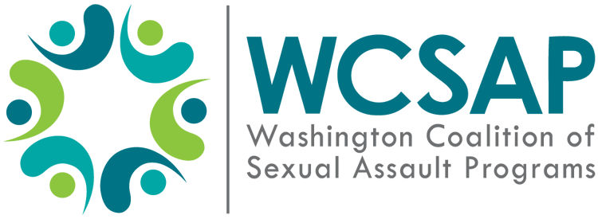
Board of Directors Meeting Minutes
Date: Wed, January 19, 2022
Board members present: Angie Pacheco, Carlyn Sampson, Isabella Kent, Alex Sheehan, Toya Aubert, Jessica Johnson, Riannon Bardsley
Board members absent: Jayne Clifford, Debra Brockman, Dawn Brumfield
Staff present: None.
Guests present: None.

Agenda item | Notes
Welcome | Meeting called to order at 3:10PM.
Roll Call | Roll Call was conducted by Alex.
Consent Agenda | Motion to approve November 2021 Meeting Minutes made by Jessica. Isabella seconded. No abstentions. Unanimously passed at 3:25PM.
Compensation Equity Committee Update | - Proposal made by joint staff/board committee. Review was conducted on all related policies to make sure WCSAP reflects current values enclosed with policies.  - Proposal made to use a flat rate for annual COLA increases for employees, instead of using COLAs as a percentage based upon salary.  - Proposal made to provide unlimited sick leave.  - Proposal made to provide a flat fee stipend for telecommuting/remote work.  - Proposal made to establish annual minimum stipend.  - Proposal made to include longevity bonuses for number of years in service.  - Carlyn requested we also discuss financial implications of all proposals made with a budget proposal.
Financial Reports | - Due to delayed availability, Carlyn was not able to meet with Jazmin, WCSAP’s Bookkeeper, to go over December financial reports prior to next Board Meeting. We will have financial reports for December 2021 and January 2022 for March 2022 Board Meeting. No action will be taken at January 2022 Board Meeting regarding financial reports.  - WCSAP has a contract with hotel conference center in Spokane, WA. WCSAP has until January 31, 2022, to host conference in May 2023 or pull out of conference due to COVID-19 pandemic. This would incur a one-time 30,000 dollar fee unless waived by the hotel.  - The Board will need to vote via email by Friday, 01/28/2022 on this.  - Jessica motions to approve the FY 2021 990 Report. Riannon seconds. No abstentions. Motion passed at 4:05PM.
Audit Report for FY21 – July 2020 – June 2021 | WCSAP Board reviewed the Audit letter, dated November 19, 2021, from the Auditors, NR Smith and Associates PS. Questions were answered and discussion had by present Board Members.
Executive Director Hiring Update | Angie, Donna, and Isabella conducted in three interviews for the interim Executive Director position for WCSAP. Interview panel would like to hire candidate Rebecca Nickels and her start date would be February 18, 2022. Jessica motioned to offer employment as the WCSAP interim Executive Director to Rebecca Nickels. Seconded by Isabella. No abstentions. Motion passed at 4:15PM.
Adjourn | Meeting adjourned at 4:17PM.

